AI Stock Prediction Using Japanese Candlestick Patterns
For my Personal Project, I want to develop an AI Stock Prediction System.
Many people use technical analysis to understand whether the price of a stock might go up or down. A well-known example is Japanese Candlestick Patterns. My idea is to use these patterns together with Machine Learning to predict stock price movements.
The application will collect historical data from different stocks, such as the open, high, low, and close prices and trading volume.
The system will then analyze different candlestick patterns, such as Doji, Hammer, Bullish Engulfing, and Bearish Engulfing. I will also use technical indicators such as RSI, Moving Averages, and MACD.
Using this information, I will train a Machine Learning model. The model will use historical data to predict whether the price of a stock is likely to go up or down in the coming days.
For example the Open price is 16, the highest price is 17, the lowest price is 8, and the Close price is 15. This makes a small body with a long line under it. My code checks the shape of the candle. If it looks like a Hammer, the code saves Hammer as 1. If not, it saves it as 0.
Based on this prediction, the system will give one of the following signals:
BUY, SELL, or HOLD
The user can choose a stock, for example Apple, Tesla, Microsoft, or NVIDIA. In the interface, the user will be able to see the stock chart, the prediction, and the probability.
The system will also show how confident the AI model is about its prediction. For example:
Probability UP: 72%
Probability DOWN: 28%
System signal: BUY
What Problem do I Want to Solve?
For many people, analyzing stocks can be difficult. There are many charts, candlestick patterns, and technical indicators, and it can be difficult to understand all this information.
With my project, I want to make stock analysis easier and clearer. Normally, users have to look at many charts and indicators themselves. My system will do most of this analysis for them. The Machine Learning model will process the information and provide a prediction.
The system can help users understand a stock better and decide whether they want to buy, sell, or hold it.

What do I want to Learn?
With this project, I mainly want to learn more about Machine Learning. I want to learn how to prepare historical data and use it to train a Machine Learning model.
I also want to learn how Machine Learning finds patterns in historical data and uses them to make predictions. In addition, I want to learn how to evaluate the model and understand how accurate its predictions are.

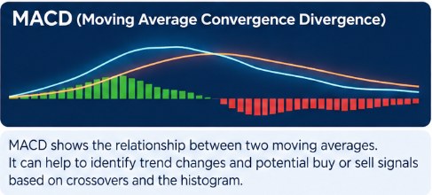
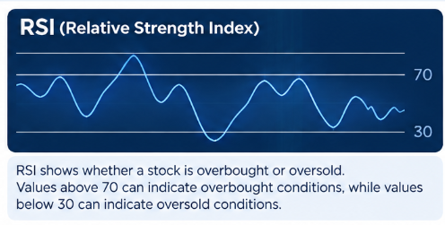
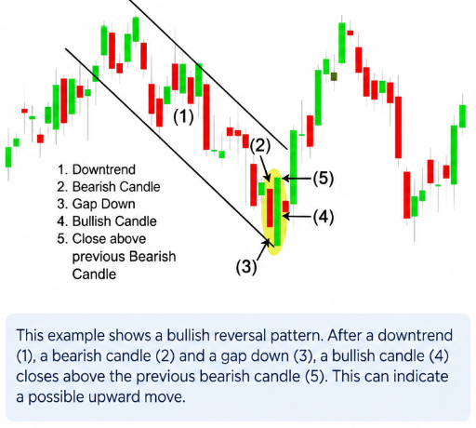
Example of candlestick patterns, RSI, and MACD that the system will use to analyze stocks:

